- Walking Water
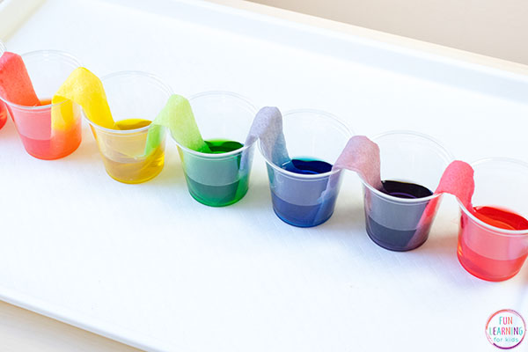

Needed:
Small plastic cups or glasses
Paper towels (*read the tips below for picking the right ones)
Food colouring in primary colours
Water
The pick-a-size paper towels are best because then you just use half sheets for each cup. If you only have full sheets, then cut them in half. I’ve also heard that more absorbent paper towels work better too. I buy the cheap store brand ones, and our water moved pretty quickly from cup to cup, so I am not sure how important that is. It may have gone quicker with something more absorbent though.
1. Print out the recording sheets and make copies, if needed.
2. Place 7 cups in a row and pour water in the 1st, 3rd, 5th, and 7th cup. My cups were about 3/4 full. I have since heard that fuller is better.
3. Add 5 drops of red food colouring to the 1st cup and the 7th cup.
4. Add 5 drops of yellow food colouring to the 3rd cup.
5. Add 5 drops of blue food colouring to the 5th cup.
You want to try to use the same amount of food colouring in each cup. You can just add a drop or two more to the others to even it out.
6. Take a half sheet of paper towel and fold it in half lengthwise and in half again lengthwise.
7. Trim off some of the length so that there isn’t too much excess paper towel that will stick up in the air between each cup. This will make the water walk more quickly.
8. Place one half of a rolled paper towel in the 1st cup and place the other half in the cup next to it. Then another paper towel from 2nd cup and into the 3rd cup. This continues until you have placed the last paper towel that drapes over from the 6th cup to the 7th cup.
9. Stare at the cups and watch what starts happening. You should quickly be able to see the coloured water begin to crawl up the paper towel.
10. Don’t forget to do the first part of the recording sheet. Students will predict what they think will happen.

- Magic Milk
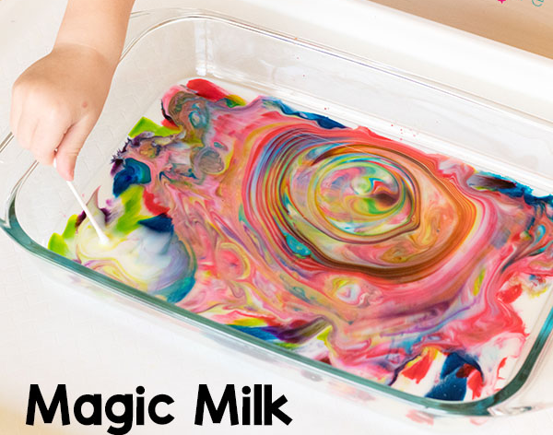

Needed:
Milk
Liquid food colouring – gel doesn’t work well
Dish soap
Cotton swabs
That’s all you need! I bet you have most of them already.
It’s also super simple to set up.
1. Pour a thin layer of milk in a shallow pan.
2. Have the children add drops of food colouring all around in the milk.
3. Then the children will pick up a cotton swab and dip it in the dish soap.
4. Then put the cotton swab in the milk – pressing it down in one spot and holding it there for about 15 seconds.
Watch what happens!
How Does the Magic Milk Experiment Work?
Some useful questions about the investigation:
What did you notice?
What happened when you put the cotton swab in the milk?
Why do you think that happened?
Why do you think it stopped moving around after a period of time?
What else did you observe?

- Lava Lamp
Needed:
Vegetable Oil
Water
Food colouring – primary colours or neon
Original Alka Seltzer tablets

- To begin, colour about 1/2 cup of water with food colouring. I like using these gel food colours for vibrant colouring.
- Take the Alka Seltzer tablets and break them into 2 or 3 pieces. Place them in a small cup or container.
- Fill a glass about 3/4 full with vegetable oil. Then pour in the coloured water until the liquid in the cup is about 3-5cm from the top.
- You don’t want it to overflow! Well, unless you want to turn it into an eruption experiment too. For this reason and quick clean-up, I like to do this on a tray.
- Let the children take turns adding a piece of an Alka Seltzer table to the cup. *DO NOT let them put the tablet in their mouth at any time.

Science behind the investigation:
The water and oil do not mix and the oil doesn’t change colour because the food colouring is water soluble. The Alka Seltzer reacts with the water to make bubbles of carbon dioxide. The bubbles attach themselves to the blobs of coloured water and bring them to the top of the glass. When the bubbles pop the blobs of coloured water fall back to the bottom of the glass.

- Skittle Patterns or Rainbows
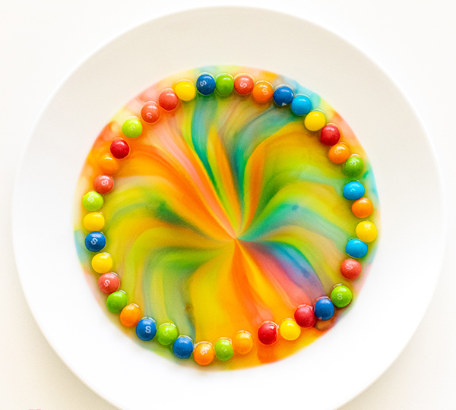
Needed:
Plate
Warm water
Skittles (Try different colours and flavours!)
Instructions:

- Grab your plate and organize the Skittles in a circle around the edge of the plate. Childrens can try different colour patterns each time they do the experiment!
- Gently pour water in the centre of the plate. Warm water works better than cold. Make sure there is enough water to go past the Skittles while filling the plate.
- Wait and watch the Skittles colours move towards the centre of the plate with beautiful rainbow streaks.

Science behind the investigation:
Skittles are coated with sugar and food colouring. When you add warm water to the Skittles, the sugar and food colouring start to dissolve. They have similar amounts coated on them so they dissolve at similar speeds and stay in their lanes.

5.Rain Cloud in a Jar

Needed:
A large jar (plastic)
Shaving cream (not a gel)
Gel Food colouring or washable watercolours
Pipettes or droppers

- In a small cup, mix the food colouring with some water.

- Fill the large jar with water until it is about 3/4 full.

- Place the jar and the cups of coloured water on the table. Place a pipette in each cup of coloured water.

- Right before the children are ready to do the experiment, spray a bunch of shaving cream in the jar until it is just a small bit above the top of the jar.

- Ask the children to pick up some coloured water with a pipette and squirt it on top of the shaving cream cloud. Repeat this step one or two more times, but pay close attention to what is happening below the cloud!
- The coloured water will begin to seep down through the shaving cream and into the water below. Just like rain!
Science behind the investigation:
The shaving cream represents the clouds and the water represents the air. The coloured water represents rain. As the coloured water saturates the “cloud”, it gets heavy and eventually is so heavy that it can no longer hold the water. It “rains” down into the jar – through the “air.” It is just like real rain falls through the air.
6. Dancing Raisins Science Experiment

Needed:
Soda or another clear soda (7-Up, Sprite, etc.) (Unopened is best)
Raisins (fresh works best)

*Tip: You will want to separate the raisins first. If they are stuck together, they won’t dance. Small/medium raisins worked better as well.

- Fill a glass with soda.
- Drop raisins into the glass. What happens? Do they sink or float?
- Then sit and watch what happens. You may need to be patient. It can take a minute or two for them to start moving.

Science behind the investigation:
When you first drop the raisins in the soda they sink to the bottom of the glass because they are denser than the soda. But the carbonated soda releases carbon dioxide bubbles and these bubbles love to attach to the rough surface of the raisins. They act like tiny floatation devices that lift the raisin to the surface of the water. This is due to an increase in buoyancy.

Once the carbon dioxide bubbles reach the surface of the soda they pop and the gas is released into the air. This makes the raisin lose buoyancy and fall back down to the bottom of the glass.

This continues until all of the carbon dioxide has escaped and the soda is flat.

7.Winter Blizzard
Needed:
White paint
Water
Baby oil
Original Alka-Seltzer
A glass or jar

- In a small cup or bowl, mix about 1 tablespoon of white paint with a cup of water.
- Pour the baby in a tall glass or jar until it is about 1/2-2/3 full.
- Pour the white water into the oil.
- Break the Alka-Seltzer tabs in quarters and put them in a small cup.
- Children will take a piece of an Alka-Seltzer tab and drop it in the glass. *DO NOT let them put the tablet in their mouth at any time.
- They will soon see the white water start to bubble up in the glass. It will rise up to the top of the oil and then drop back down over and over again.
- The more pieces of Alka-Seltzer you drop in the more it bubbles up. Just be careful, if you add too much it might bubble over the top of the glass!

Science behind the investigation:
The water and oil do not mix and the oil doesn’t change colour because the food colouring is water-soluble. The Alka-Seltzer reacts with the water to make bubbles of carbon dioxide.
The bubbles attach themselves to the blobs of coloured water and bring them to the top of the glass. When the bubbles pop the blobs of coloured water fall back to the bottom of the glass.

8.Oil and Water
Needed:

Baby oil or vegetable oil (depends on if you want it to be clear)
Washable liquid watercolours or food colouring
Pipettes or droppers

*If you decide to use baby oil and watercolours, make sure your children won’t put this in their mouths!

- Put water in several cups and add food colouring or liquid watercolours to the water. Then stir to combine.
- Place a pipette in each coloured glass of water.
- Fill a cup about half way with oil.
- Let them explore the different colours.

Science behind the investigation:

While enjoying this science exploration children will explore how oil and water do not mix together. It is a great start to simply explore the two liquids and see how they behave when mixed together.

9.Changing the colour of Celery or cabbage leaves.
(One to leave overnight).
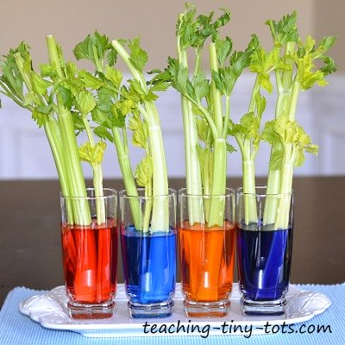

Needed:
Clear glass jars, cups or small clear vase
Fresh Celery stalks with leaves. Preferably the lighter leafier stalks near the centre.
Water
Food Colouring
- Separate and select stalks of celery with leaves. Cut about a 1cm off the bottom. The lighter stalks near the centre will show the most colour.
- Put about 100ml of water into glass jar or vase.
- Drop 3-4 drops of food colouring into jar.
- Place stalks into the water and using stalk stir very gently until food colouring is dispersed evenly.
- Have child/class make predictions about what will happen.
- Make 2-3 observations and write them down. Check at intervals depending on availability, you will see slight results after 3 hours, significant results overnight and again at 48 hours.
- Cut the bottom of the celery and you can see where the water was transported up into the celery stem.

Science behind the investigation and after:
How a plant absorbs water. This process is called Osmosis. The coloured water should of moved up the celery stick, this is how water moves up in a plant.
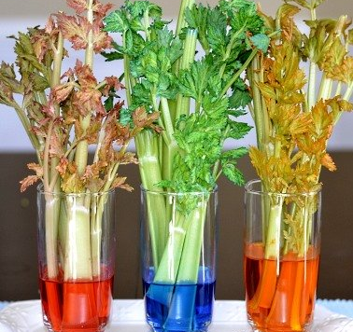
10. Dry Erase Floating Writing

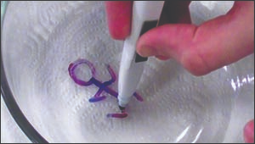

A glass plate, bowl, or picture frame
Dry erase marker
Water

- Draw a simple picture on the glass. A stick figure is a good one to start with.
- Pour water onto the plate or into the bowl slowly to lift up the drawing.
- Swirl the water around to make the picture dance and move.

Science behind the investigation and after:
The marker leaves behind mixture of pigments and a type of alcohol mixed together. The alcohol dissolves and the pigments are left behind as a solid. Glass is so smooth that the solid slides right off when it gets wet!

11. A Volcano
Needed:
10 ml of washing up liquid
100 ml of cold water
400 ml of white vinegar
Food colouring
Baking soda slurry (fill a cup about ½ with baking soda, then fill the rest of the way with water)
Empty 2 litre bottle

NOTE: This should be done outside due to the mess.
- Combine the vinegar, water, dish soap and 2 drops of food colouring into the empty soda bottle.
- Use a spoon to mix the baking soda slurry until it is all a liquid.
- Eruption time! … Pour the baking soda slurry into the soda bottle quickly and step back!

Science behind the investigation and after:
A chemical reaction between vinegar and baking soda creates a gas called carbon dioxide. Carbon dioxide is the same type of gas used to make the carbonation in sodas. What happens if you shake up a soda? The gas gets very excited and tries to spread out. There is not enough room in the bottle for the gas to spread out so it leaves through the opening very quickly, causing an eruption!

12. Rainbow in a Glass
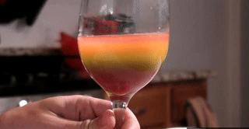
Needed:
Skittles
Water
A mug
5 separate cups
A Tablespoon
A clear glass
A dropper or pipette
- Separate the Skittles into the cups, in these amounts: 2 red, 4 orange, 6 yellow, 8 green, and 10 purple.
- Heat a mug of water in the microwave for a minute and a half (or long enough that the water is hot, but not boiling). Be careful removing the water from the microwave–it’s hot!
- Measure and pour two tablespoons of hot water into each cup, on top of the Skittles.
- Stir each cup carefully so no water splashes out. The cups need to be cool for the next part of the experiment, so leave them somewhere where they won’t get knocked over. Stir them every ten minutes or so until the Skittles are dissolved and the water is room temperature.
- Using the dropper, add the coloured water from the five cups to the clear glass. Start with purple, then add green, then yellow, orange, and red last. Go slowly here, we don’t want the different layers to mix.

Science behind the investigation:
Skittles are mostly made of sugar. When you add hot water to them, the sugar dissolves and the colouring on the shell of the Skittles turns the water different colours. The cup with only two red Skittles doesn’t have as much sugar as the cup with ten purple Skittles, but they both have the same amount of water. The amount of matter packed into a certain amount of space is called the density of the material. The red water is less dense than the purple water, so it will float on top of the purple water.

